SOFWARE TOOLS

Group Project - PART 1

Submitted By: Students Mykhailo Hnylytskyi | Oleh Bodnar | Philip Filippenko
Computing with Games Development/Software Development

Date Submitted: dd/mm/yyyy

Contents
1. Introduction/overview 3
2. Functional Components 4
3. User Requirements 5
3.1. PHP Bank System will manage Accounts 5
3.2. PHP Bank will process reservations 5
3.3. PHP Bank will be adding founds on own Account 5
4. User Stories 6
4.1. System Level Use Case Diagram 7
4.2. Manage Accounts 8
4.2.1. Sign in Account 8
4.2.2. Update Account 10
4.2.3. Close Account 12
4.3. Management 13
4.3.1. Check Transaction History 13
4.3.2. Enable 2FA 14
4.4. Money Transfer 15
4.4.1. Add Funds 15
4.4.2. Send Money 17
4.4.3. Display Confirmation 19
5. System Model 21
5.1. Level-0 DFD 21
5.2. Level-1 DFD 21
5.3. Level-2 DFD (Process P1: Title) 21
5.4. Level-2 DFD (Process P2: Title) 21
5.5. Level-2 DFD (Process P3: Title) 21
6. Data Model (UML Class Diagram) 22
6.1. Class Diagram 22
6.2. Relational Schema 23
6.3. Database Schema 23
7. Conclusion 25

Introduction/overview
Running a modern banking institution comes with its own set of complex challenges. From customer account management to transaction processing to regulatory compliance, it's a demanding process if you don't have the right technological infrastructure in place. The PHP Bank System solves all these needs by providing a comprehensive and secure way of managing daily banking operations, reducing the amount of manual work and increasing overall efficiency and security.
The system focuses on four main areas:
Account management: A unified system for the smooth creation, updating and management of customer bank accounts. Transaction processing: Tools to monitor and process all types of financial transactions including deposits, withdrawals, and balance inquiries. Transfer management: An intuitive workflow for internal and external transfers, cancellations and processing to keep operations running smoothly. Reporting and analytics: Features to generate key insights, such as monthly statements and transaction analysis, to help managers make informed decisions and ensure regulatory compliance.
The PHP Bank System is developed on a robust database architecture that maintains and links information on customer accounts, transaction histories and transfer records. This ensures complete accuracy in tracking all financial activities while minimizing the risks associated with manual errors and ensuring regulatory compliance.
This document provides a detailed breakdown of the system's features, capabilities and technical design. It serves as a guide to understanding how the system meets the operational needs of a modern banking institution, whether it's a small community bank or a growing financial services company. By automating key tasks and centralising operations, the PHP Bank System saves time, increases accuracy, ensures compliance and improves the overall experience for both administrators and customers.

Functional Components

User Requirements

PHP Bank System will manage Accounts
    - PHP Bank System will create a customer account.
    - PHP Bank System will update account details.
    - PHP Bank System will close an account.

PHP Bank will process reservations
    - PHP Bank will make a reservation

PHP Bank will be adding founds on own Account
    - PHP Bank will send money to other Accounts
    - PHP Bank will display confirmation

User Stories
Epic: Account Access and Authentication
- User Registration
As a New Customer
I want to register for online banking
So that I can perform the transactions.
Acceptance Criteria –
- Users must provide valid email, phone number, and personal information
- System validates email and sends verification code
- Password must meet security requirements (....)
- Account creates after email validation

- User Login
As a Registered Customer
I want to log in to my account
So that I can access my banking account

Acceptance Criteria –
- Users must provide email and passwords.
- System validates email and password
- After 3 failed login attempts, account is locked for 15 minutes
- Account creates after email validation

Epic: Account Management
- View Account Dashboard
As a customer
I want to see my account in dashboard
So that I can understand status of my funds

Acceptance Criteria –
- Customers must be logged in to view dashboards
- Display all linked accounts (cards, savings, ....)
- Show balance for each account
- Display of 5 recent transactions

- View Transaction History
As a customer
I want to see all my transaction history
So that I can understand my spending/financial situation

Acceptance Criteria –
- Display transaction details: date, description amount
- Customer can filter transaction by date and type withdrawal, transaction, savings,
- Functionality to download transaction history as PDF file

Epic: Money Transfer

- Internal Transfer
As a customer
I want to transfer money between my own accounts
So that I can manage my funds

Acceptance Criteria –
- Customers select source and destination account
- System validates balances in account and procced transaction
- Display transfer confirmation notification/message

- External Transfer
As a customer
I want to transfer money to other accounts
So that I can send money to other people

Acceptance Criteria –
- Customers must provide other account details
- System validates account details and both user funds
Display transfer confirmation notification/message

System Level Use Case Diagram
Manage Account
Security
Manage Transaction
Customer

Manage Accounts

This module provides functions to manage the lifecycle of customer accounts, including creating new accounts, updating details, and closing accounts that are no longer operational. These features make it super easy to keep the customer account database updated and organised.

Sign in Account
This high priority use case allows a customer to create a new account. The process begins when the customer selects "Create Account." The system prompts for required details (name, DOB, phone, email, password), validates them (format, uniqueness, age), and, if valid, creates an account with a unique number. Errors trigger messages and re-entry. Once complete, the account is ready for use.
Use Case Name | Sign in Account
Use Case Id | 01
Priority | High
Source | Customer
Primary Business Actor
Other Participating Actors
Description | This function records a customer account details in the system.
Preconditions
Trigger | A customer creates a new account in the system.
Expected Scenario | Customer | System
 | Step 1: Customer invokes the Create Account Function  Step 4: The Customer enters the required data:  • FirstName String (30)  • LastName String (30)  • DOB Date  • PhoneNo String (15)  • Email String (50)  • Password String (20) | Step 2: Display UI.  Step 5: The system validates the data entered:  • All fields must be entered  • FirstName, LastName must not be numeric  • Phone number must contain only digits  • Email must comply with standard email format  • Password must be at least 8 characters  • DOB must indicate customer is 18+ years old  • Email and PhoneNo must be unique  Step 6: Generate unique AccountNo  Step 8: Save details in the Account File:  • AccountNo  • FirstName  • LastName  • DOB  • PhoneNo  • Email  • Password  Step 9: Display Confirmation Message  Step 10: Reset UI
Alternate Scenarios | Customer | System
Invalid Data Entered |  | Step 5: Validation test fails  Step 6: Display and appropriate error message  Step 7: return to Step 4
Conclusions | The Account details have been saved in the system
Post conditions | Account can now be used for transactions.
Business Rules
Implementation Constraints

Update Account
This function allows customers to update their account details in the system. Each account is uniquely identified by its account number.
Use Case Name | Update Account
Use Case Id | 02
Priority | High
Source | Customer
Primary Business Actor | Customer
Other Participating Actors
Description | This function updates details of customer account in the system.
Preconditions | The customer account must already exist in the system.
Trigger
Expected Scenario | Customer | System
 | Step 1: Starts Update Account function.  Step 4: Update the required data:  - FirstName  - LastName  - DOB  - PhoneNo String (15)  - Email String (50)  - Password String (20) | Step 2: Retrieve customer account details from the Account file  Step 3: Load on UI:  Step 5: Validate the data:  • All fields must be entered.  • Phone number must contain only digits  • Email and PhoneNo must be unique  Step 6: Update the required data:  Step 7: Display Confirmation Message and Reset UI
Alternate Scenarios | Customer | System
Invalid Data Entered |  | Step 3: Display Message: "No details found"  Step 4: Terminate Application Return to main menu  Step 5: Display an appropriate error message.
Conclusions | The Account details have been updated in the system
Post conditions | Account updated and can now be used with new details.
Business Rules
Implementation Constraints

Close Account
This function closes a customer account in the system. It updates the account's status to indicate that it is no longer available for transactions.
Use Case Name | Close Account
Use Case Id | 03
Priority | High
Source | Customer
Primary Business Actor | Customer
Other Participating Actors
Description | This function closes a customer account in the system.
Preconditions
Trigger | The customer no longer wants to use the account.
Expected Scenario | Customer | System
Customer closes account in the system | Step 1: Starts Close Account functions  Step 3: Confirmation of closure action | Step 2: Retrieve account details from the Account file  Step 5: Status is set to closed ('C') in Account file
Alternate Scenarios | Customer | System
No account data found |  | Step 4: Display error message  Step 5: Return to main menu
Conclusions | The Account details have been closed in the system
Post conditions | The account is marked as closed and is no longer available for transactions.
Business Rules | An account cannot be closed if it has pending transactions or transfers.
Implementation Constraints

Management

Check Transaction History
View current account balance and recent transaction history for record-keeping.

Use Case Name | Check Transaction History
Use Case Id | 04
Priority | High
Source | Customer
Primary Business Actor | Customer
Other Participating Actors
Description | View current account balance and recent transaction history for record-keeping.
Preconditions
Trigger | The customer no longer wants to see his funds
Expected Scenario | Customer | System
Customer closes account in the system | Step 2: The customer clicks on Transactrion History buttom | Step 1: Retrieve account data from Account file to be displayed on UI:  - Current Balance  - Last Transaction History  Step 3: Display recent transaction history
Alternate Scenarios | Customer | System
No account data found |  | Step 4: Display error message  Step 5: Return to main menu
Conclusions | The use case concludes when the system successfully displays the account balance and information to the customer, presenting all relevant details of the account. At this point, the customer can choose to either check transaction history or return to the home or dashboard. The process ends based on the action selected by the customer.
Post conditions
Business Rules

Enable 2FA
This use case describes the process by which a customer enables two-factor authentication (2FA) for their account. The function enhances account security by sending a 6-digit verification code to the customer's registered email address, which the customer must enter to complete the process.
Use Case Name | Enable 2FA
Use Case Id | 05
Priority | High
Source | Customer
Primary Business Actor | Customer
Other Participating Actors
Description | This function enables two-factor authentication by sending email verification with 6-digit code.
Preconditions | The customer account must exist and be active with valid email address.
Trigger | Customer wants to enhance account security.
Expected Scenario | Customer | System
Customer closes account in the system | Step 1: Starts Enable 2FA function.  Step 3: The Customer enters required data:  • Email String (50)  Step 6: Enter the 6-digit code from email | Step 2: Display UI.  Step 4: Validate the data:  • AccountNo must exist in system  • Account must be active  • Email must match account email  Step 5: Generate 6-digit verification code and send  Step 9: Validate the entered code:  • Code must match sent Code  • Code must be exactly 6 digits  Step 10: Update Account file  :• Set TwoFAEnabled to 'Y  'Step 11: Display confirmation message and Reset UI
Alternate Scenarios | Customer | System
Invalid verification code |  | Step 9: Code validation fails  Step 10: Display message "Invalid verification code"  Step 11: Return to Step 8
Email not received |  | Step 7: Email sending fails  Step 8: Display message "Email could not be sent"  Step 9: Return to Step 3
Conclusions | Two-factor authentication has been enabled successfully after email verification
Post conditions | Account security is enhanced with 2FA protection. User will need 2FA for future logins.
Business Rules | 2FA can only be enabled with valid email verification. Once enabled, 2FA will be required for login access.
Implementation Constraints

Money Transfer
This module enables users to manage and execute financial transactions efficiently. Users can add
funds to their account, send money to external accounts, and view confirmation details of completed transfers to ensure accuracy and transparency.

Add Funds
Load money into your account from linked sources.
Use Case Name | Add Funds
Use Case Id | 06
Priority | 1
Source | Customer
Primary Business Actor | Customer
Other Participating Actors
Description | This function add money to account
Preconditions
Trigger
Expected Scenario | Customer | System
 | Step 1: Customer invokes the Add Funds Function  Step 3: The Customer enters the required data:  - Card Holder Name  - Card Number  - Expire Date  - CVV  - Top-Up Amount | Step 2: The system displays the UI for account creation  Step 4: The system validates the data entered:  Card Holder Name:  - Must contain only letters and spaces (no numbers or special characters)  - Length: 2 to 50 characters  Card Number:  - Must be 13 to 19 digits.  - Digits only (no spaces or dashes)  Expire Date:  - Format: MM/YY or MM/YYYY  - Must be a valid future date  - Month must be between 01 and 12  - Should not be in the past  CVV:  - Must be 3 digits  - Digits only.  Value:  - Must be a positive number  - Can include up to 2 decimal places  - Minimum amount: e.g., $1.00 (adjust as needed for your business rules)  - Maximum amount: e.g., $10,000.00 (optional cap to prevent abuse or fraud)  - No letters, special characters, or commas.  - Must not be zero or negative  Step 5: The system adds to current balance the top-up amount  Step 6: The system saves the balance:  - Balance  Step 7: The system displays a confirmation message  Step 8: The system resets the UI
Alternate Scenarios | Customer | System
Invalid Data Entered |  | Step 4: Validation test fails  Step 5: Display and appropriate error message  Step 6: return to Step 3
Conclusions | The top-up process is completed successfully after all inputs are validated.
Post conditions | The account balance is updated with the top-up amount and saved in the accounts file.
Business Rules
Implementation Constraints

Send Money
Transfer funds securely to external bank accounts or recipients
Use Case Name | Send Money
Use Case Id | 07
Priority | 1
Source | Customer
Primary Business Actor | Customer
Other Participating Actors
Description | Transfer funds securely to external bank accounts or recipients
Preconditions
Trigger
Expected Scenario | Customer | System
 | Step 1: Customer invokes the Send Money Function  Step 3: The Customer enters the required data:  - Card Holder Name  - Card Number  - Message  - Total Amount | Step 2: The system displays the UI for account creation  Step 4: The system validates the data entered:  Card Holder Name:  - Alphabetic characters only (allow spaces and hyphens)  - Length 2 to 50 characters  Card Number:  - 13 to 19 digits (numeric only)  Message:  - Any characters, sanitized to prevent XSS or injection  - Length max 200 characters  Total Amount:  - Greater than 0  - 2 decimal places  Step 5: The system updates Balance in Accounts File  Step 6: The system decreases Total Amount from Balance and saves the updated balance:  - Balance  Step 7: The system displays a confirmation message  Step 8: The system resets the UI  Step 9: Displays Home menu
Alternate Scenarios | Customer | System
Invalid Data Entered |  | Step 4: Validation test fails  Step 5: Display and appropriate error message  Step 6: return to Step 3
Conclusions | The money transfer is either successfully completed with confirmation and balance updated, or it fails with clear validation errors prompting the customer to try again. The system returns to the home menu in both cases.
Post conditions | If successful, the amount is deducted, the transaction is saved, and the customer sees a confirmation. If unsuccessful, no changes occur, and the user is prompted to correct the input.
Business Rules
Implementation Constraints

Display Confirmation
View detailed summaries of successful transactions for record-keeping.
Use Case Name | Display Confirmation
Use Case Id | 08
Priority | 1
Source | Customer
Primary Business Actor | Customer
Other Participating Actors
Description | View detailed summaries of successful transactions for record-keeping.
Preconditions
Trigger
Expected Scenario | Customer | System
 | Step 2: The customer option in this UI  - Send Money Again  - Return to Home / Dashboard | Step 1: Retrieve data from Send Money function to be displayed on UI:  - Transaction Status: Successful or Failed  - Date & Time  - Recipient/Card Holder Name  - Card Number (Masked)  - Amount Sent  - Message (if provided)  - Remaining Balance
Alternate Scenarios | Customer | System
Send Money Again  Return to Home / Dashboard | Step 2: Click on this option  Step 2: Click on this option | Step 3: return to Send Money function  Step 3: Return to Home / Dashboard
Conclusions | The use case concludes when the system successfully displays the transaction confirmation screen to the customer, presenting all relevant details of the transaction. At this point, the customer can choose to either send money again or return to the home or dashboard. The process ends based on the action selected by the customer.
Post conditions | After the use case is completed, the transaction details have been displayed for the customer's review. The transaction is recorded in the system for reference or future use. The customer is presented with options to proceed, but no further system activity occurs unless the customer initiates a new action.
Business Rules
Implementation Constraints

System Model
The following dataflow diagrams have been produced for the system:

Level-0 DFD

Level-1 DFD
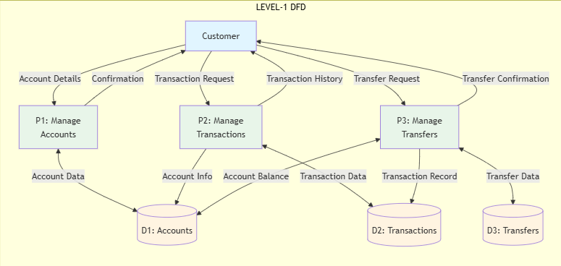

Level-2 DFD (Process P1: Title)

Level-2 DFD (Process P2: Title)

Level-2 DFD (Process P3: Title)

Data Model (UML Class Diagram)
Brief introduction……

Class Diagram
Include class diagram / Object Model – UML Class Diagram here
Class diagram shows objects & attributes (NO METHODS)
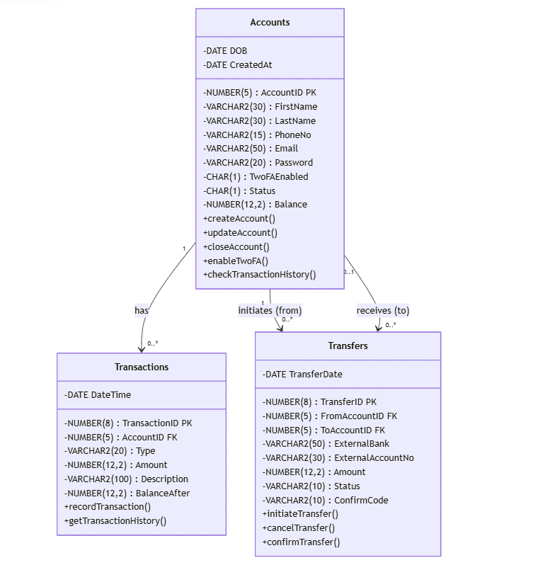

Relational Schema
Relational schema for the data requirements - Using bracket notation
Accounts (AccountID, FirstName, LastName, DOB, PhoneNo, Email, Password, TwoFAEnabled, Status, Balance, CreatedAt)
Transactions (TransactionID, AccountID*, Type, Amount, DateTime, Description, BalanceAfter)
Transfers (TransferID, FromAccountID*, ToAccountID*, ExternalBank, ExternalAccountNo, Amount, TransferDate, Status, ConfirmCode)

Database Schema
A definition of the database to be implemented.
This includes primary key, foreign key and other constraints to be implemented.

Schema: PHP Bank

Relation: Accounts
Attributes:
AccountID NUMBER(5) NOT NULL,
FirstName VARCHAR2(30) NOT NULL,
LastName VARCHAR2(30) NOT NULL,
DOB DATE,
PhoneNo VARCHAR2(15) NOT NULL UNIQUE,
Email VARCHAR2(50) NOT NULL UNIQUE,
Password VARCHAR2(20) NOT NULL,
TwoFAEnabled CHAR(1) DEFAULT 'N' CHECK (TwoFAEnabled IN ('Y', 'N')),
Status CHAR(1) DEFAULT 'A' NOT NULL CHECK (Status IN ('A','C')),
Balance NUMBER(12,2) DEFAULT 0 NOT NULL,
CreatedAt DATE DEFAULT SYSDATE

Primary Key:
AccountID

Relation: Transactions
Attributes:
TransactionID NUMBER(8) NOT NULL,
AccountID NUMBER(5) NOT NULL,
Type VARCHAR2(20) NOT NULL,
Amount NUMBER(12,2) NOT NULL,
DateTime DATE DEFAULT SYSDATE,
Description VARCHAR2(100),
BalanceAfter NUMBER(12,2) NOT NULL

Primary Key:
TransactionID

Foreign Key:
(AccountID) REFERENCES Accounts(AccountID)

Relation: Transfers
Attributes:
TransferID NUMBER(8) NOT NULL,
FromAccountID NUMBER(5) NOT NULL,
ToAccountID NUMBER(5),
ExternalBank VARCHAR2(50),
ExternalAccountNo VARCHAR2(30),
Amount NUMBER(12,2) NOT NULL,
TransferDate DATE DEFAULT SYSDATE,
Status VARCHAR2(10) DEFAULT 'Pending',
ConfirmCode VARCHAR2(10)

Primary Key:
TransferID

Foreign Key:
(FromAccountID) REFERENCES Accounts(AccountID)
(ToAccountID) REFERENCES Accounts(AccountID)

Conclusion

